
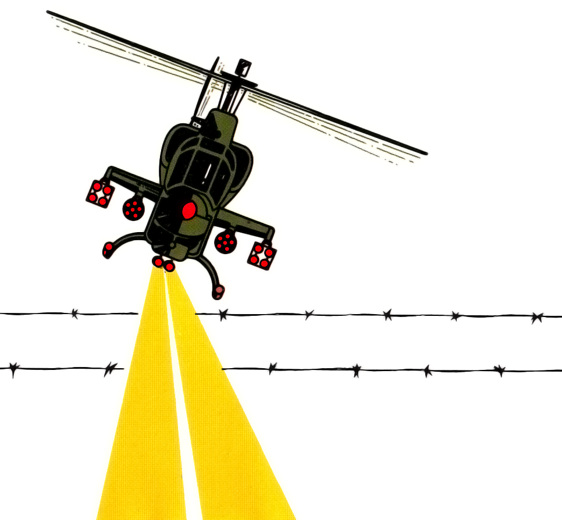
Choplifter
Choplifter
Choplifter

Pockets of international hostages are trapped. All across the world. In the Middle East. In the South Seas. And in a secret base somewhere in a cavern.

You man a helicopter rescue team. And your job is to take your helicopter down, rescue the hostages and fly them back to safety. All the while dodging and destroying dangerous enemy fire.
PLAYERS: 1 or 2
PERIPHERALS: Sega Control Pad or Control Stick
SHOOTING

