
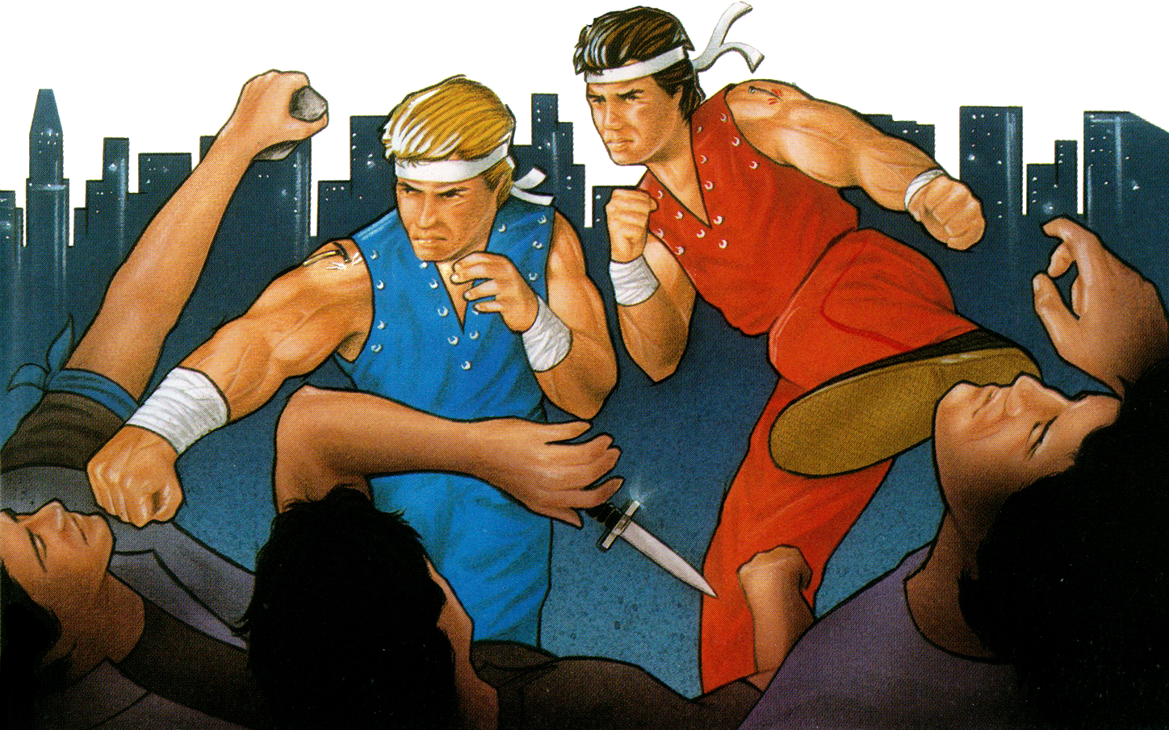
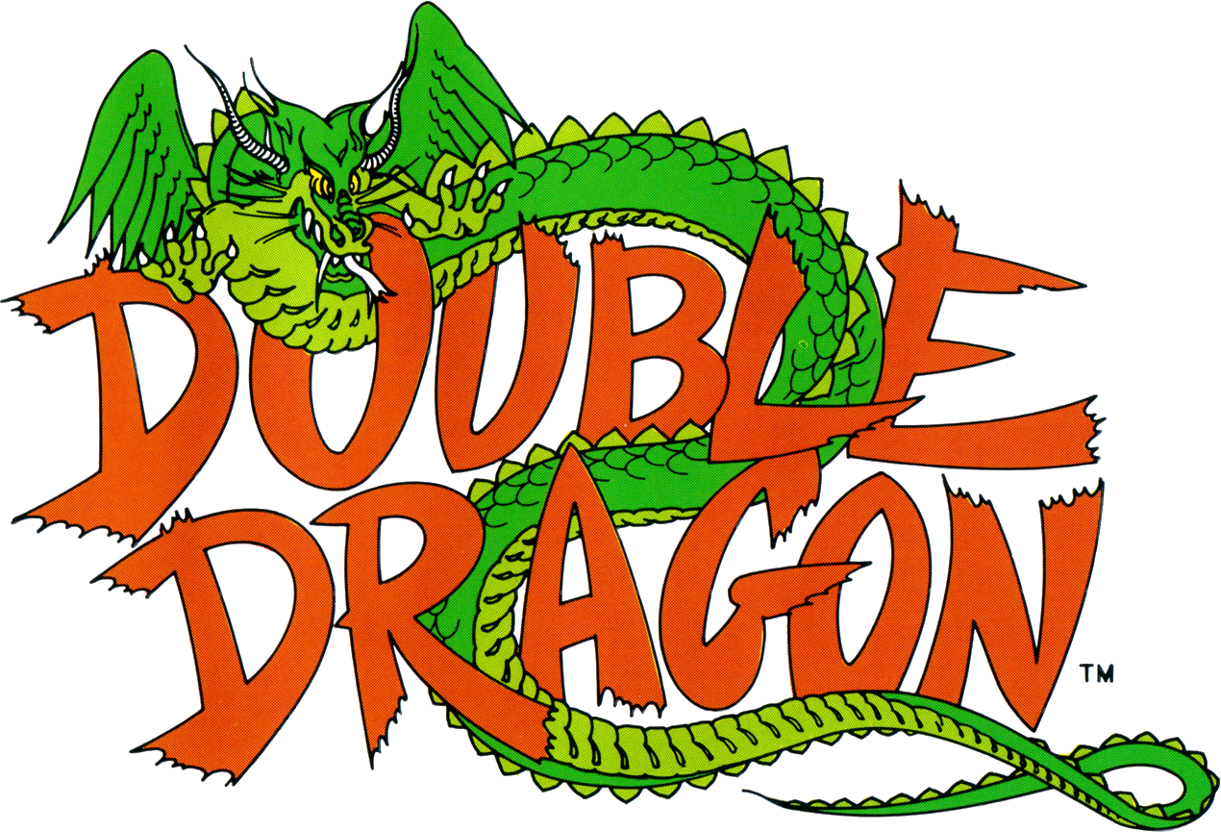
Double Dragon
Double Dragon

Using the ancient oriental martial art of Kenpo, fight your way through a city controlled by ruthless gangs of thugs.

Keep your guard up as you battle to save your sweetheart and restore the streets to law and order.

It's going to take every fighting skill you have. And if you make it to the headquarters of the Black Warriors, you'll face the greatest surprise of all, the leader of the gang!
PLAYERS: 1 or 2 players Cooperatively
PERIPHERALS: Sega Control Pad or Control Stick
ARCADE

